Project Design Phase
Solution Architecture

Date | 15 February 2025
Team ID
Project Name
Maximum Marks | 4 Marks

Solution Architecture:
The proposed system, DarshanEase – Temple Darshan Ticket Booking System, follows a modern web-based architecture designed to provide a seamless and efficient platform for devotees to book darshan slots online.
The system is divided into three primary layers: User Interface Layer, Application Layer, and Data Layer.
The User Interface Layer is developed using React.js, which provides a responsive and user-friendly web interface. Through this interface, users can register, log in, browse temples, book darshan slots, view booking history, and make donations. Administrators can manage temple information and darshan slots through an admin dashboard.
The Application Layer is implemented using Node.js and Express.js. This layer handles the core business logic of the system, including user authentication, temple management, darshan slot management, booking operations, and donation processing. The backend communicates with the frontend through RESTful APIs and ensures secure and efficient processing of user requests.
The Data Layer uses MongoDB, a NoSQL database that stores user information, temple details, darshan slots, booking records, and donation transactions. Additionally, Cloudinary cloud storage is used to store temple images and other media files.
This layered architecture ensures scalability, maintainability, and performance, allowing the system to efficiently handle multiple users and booking requests simultaneously.

Example - Solution Architecture Diagram:

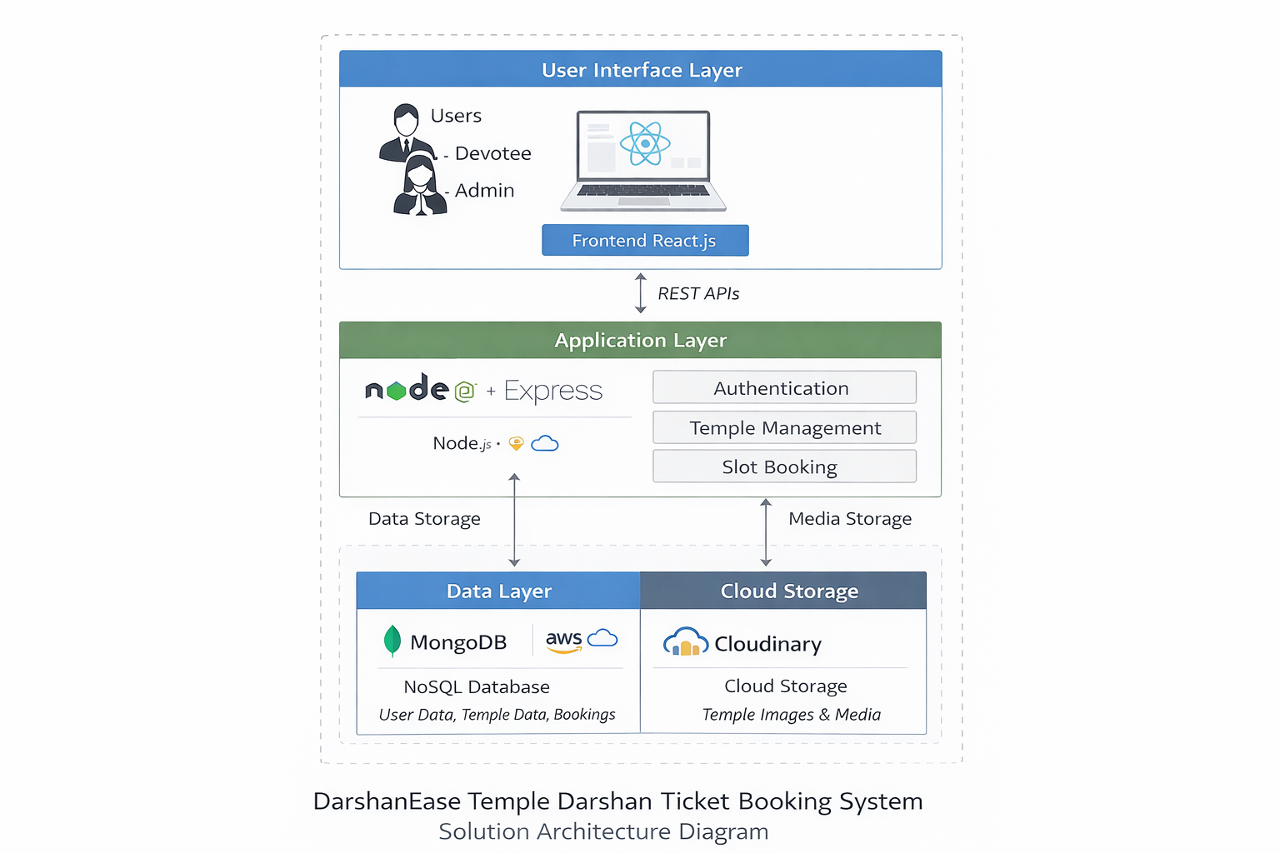
Figure 1: Solution Architecture of DarshanEase Temple Darshan Ticket Booking System
Reference: https://aws.amazon.com/blogs/industries/voice-applications-in-clinical-research-powered-by-ai-on-aws-part-1-architecture-and-design-considerations/

